Communion Eat This Bread
Jacques Berthier

Eat this bread, drink this cup, come to me and never be hungry, eat this bread, drink this cup, trust in me and you will not thirst.

Text: John 6; adapt. by Robert J. Batastini. Text and music © 1982, 1983, 1984, Ateliers et Presses de Taize (France)

Sending Forth At The Lamb’s High Feast
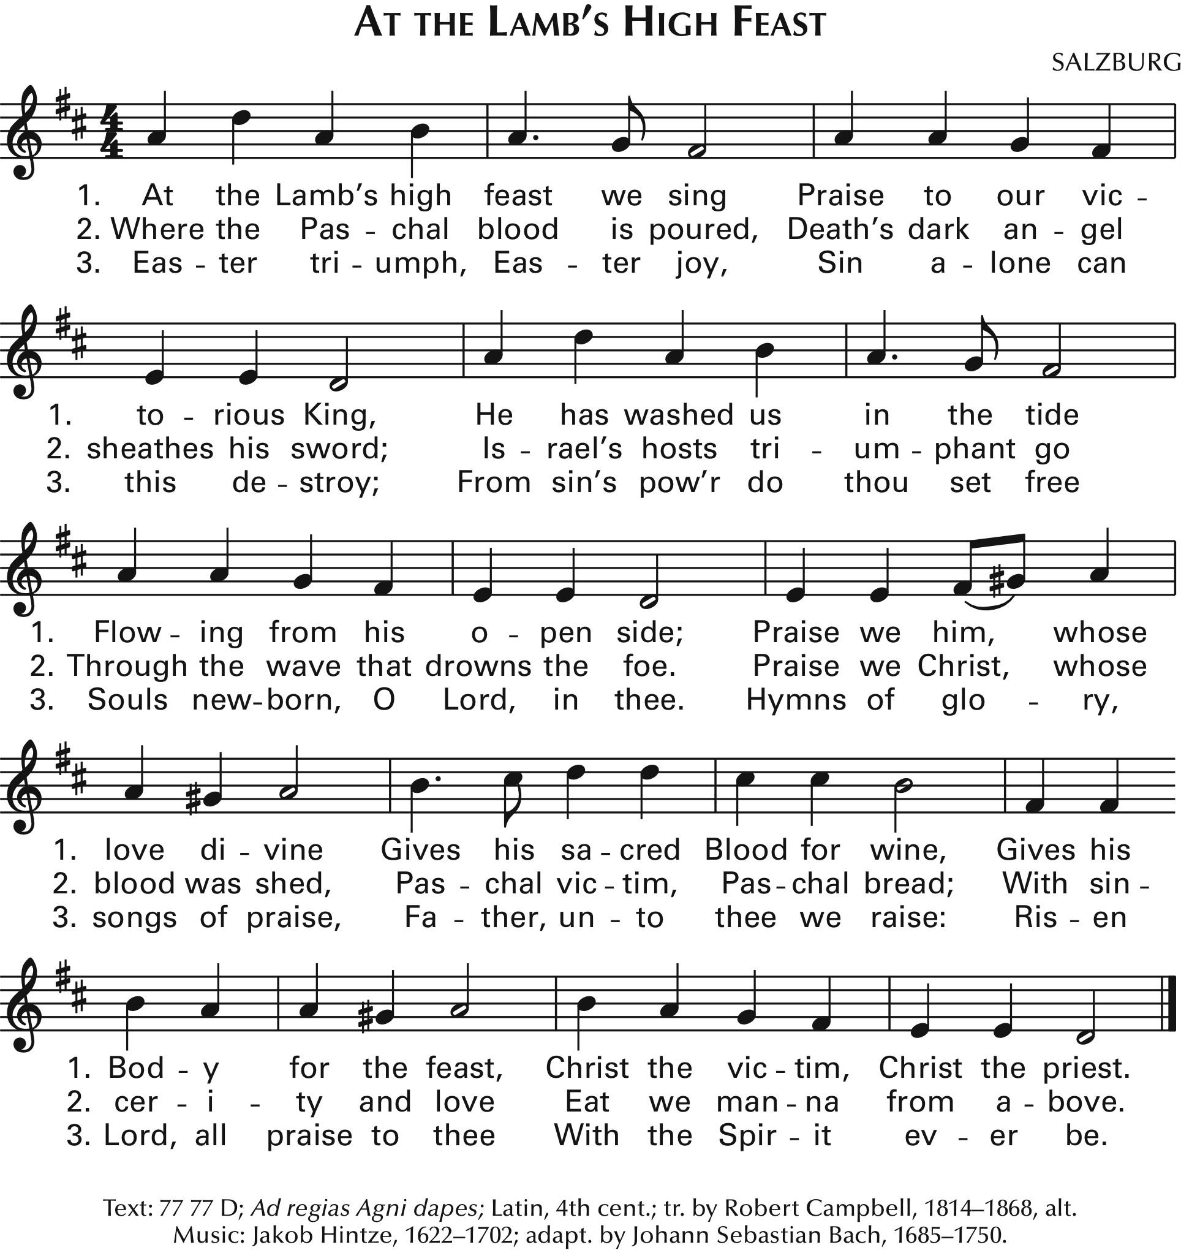

Music in this worship aid is reprinted with permission: Onelicense.net721249-A. All rights reserved.
Immaculate Conception
Catholic Church
Third Sunday of Easter, April 18, 2021

Entrance Alleluia! Love Is Alive
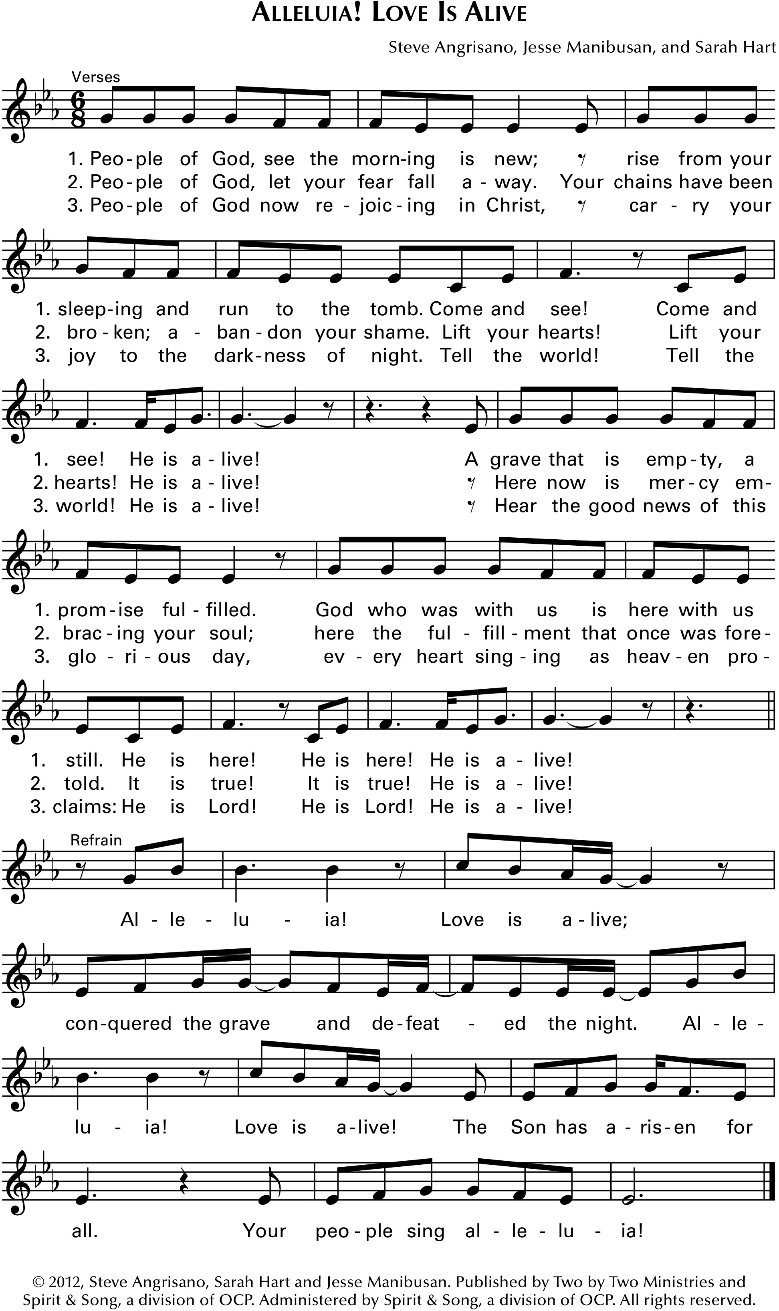

Penitential Act/Sprinkling Rite

Gloria Heritage Mass

Glory to God in the highest, and on earth peace to people of good will. We praise you, we belss you, we adore your, we glorify you, we give you thanks for your great glory, Lord God, heavenly King, O God almighty Father.

Lord Jesus Christ, Only Begotten Son, Lord God, Lamb of God, Son of the Father, you take away the sins of the world, have mercy on us; you take away the sins of the world, receive our prayer; you are seated at the right hand of the Father, have mercy on us.

For you alone are the Holy One, you alone are the Lord, you alone are the Most High, Jesus Christ, with the Holy Spirit, in the glory of God the Father. Amen

Responsorial Psalm Psalm 4
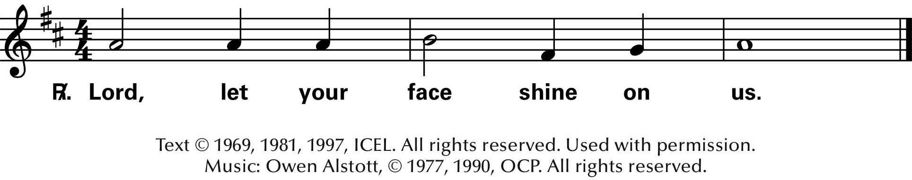

Gospel Acclamation
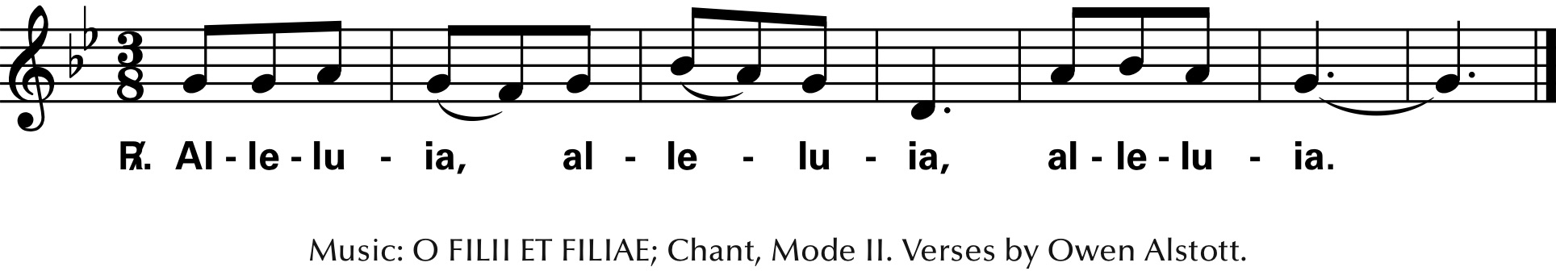

Please donate to IC Parish to keep our church and ministries running successfully!
Preparation of the Altar Two Were Bound For Emmaus
