Communion The Hand Of The Lord

Text (ref.) ©1969, 1981, 1997, ICEL. Steven R. Janco. Text (vss.) and music © 2002, WLP

Sending Forth Go Make Of All Disciples

Immaculate Conception
Catholic Church
January 17, 2021
Second Sunday in Ordinary Time

Entrance For The Healing Of The Nations
Gloria Heritage Mass
Owen Alstott
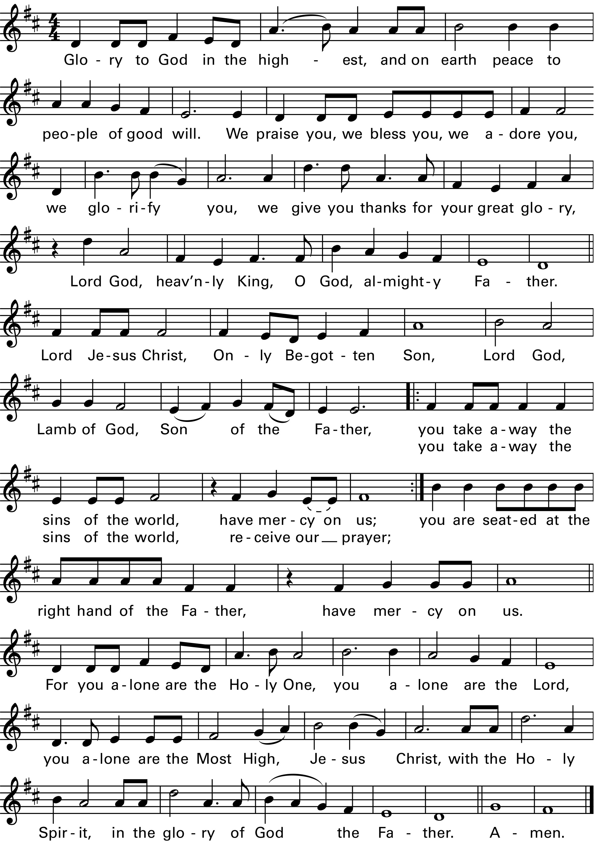

Text copyright 2010, ICEL. All rights reserved. Used with permission. Music copyright 1987, 2009, OCP

Music in this worship aid is reprinted with permission: Onelicense.net#A72564. All rights reserved.
Responsorial Psalm Psalm 40
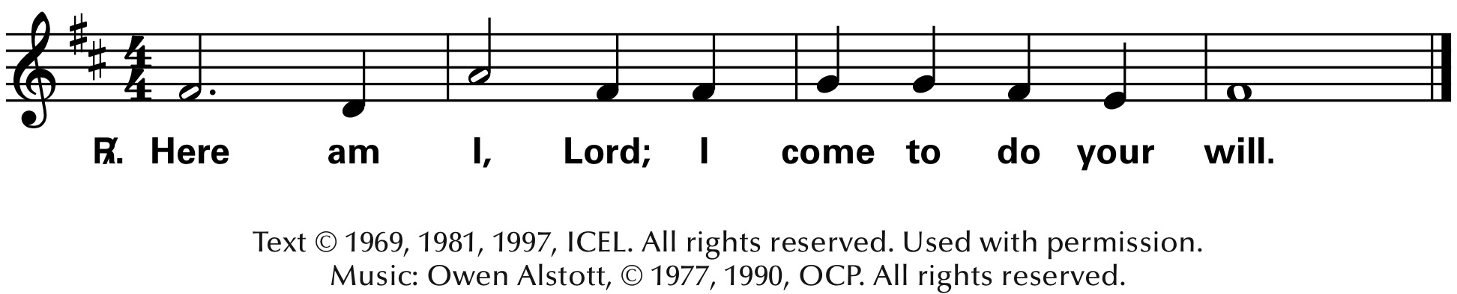

Preparation of the Altar Here I Am Lord

Verse 1:
I, the Lord of sea and sky, I have heard my people cry. All who dwell in dark and sin, my hand will save. I, who made the stars of night, I will make their darkness bright. Who will bear my light to them? Whom shall I send?

Refrain:
Here I am, Lord. Is it I, Lord? I have heard you calling in the night. I will go, Lord, if you lead me. I will hold your people in my heart.

Verse 2:
I, the Lord of snow and rain, I have borne my people’s pain. I have wept for love of them. They turn away. I will break their hearts of stone, give them hearts for love alone. I will speak my word to them. Whom shall I send?

Dan Schutte. Text: Based on Isaiah 6. Text and music © 1981, OCP. All rights reserved.

Memorial Acclamation Heritage Mass
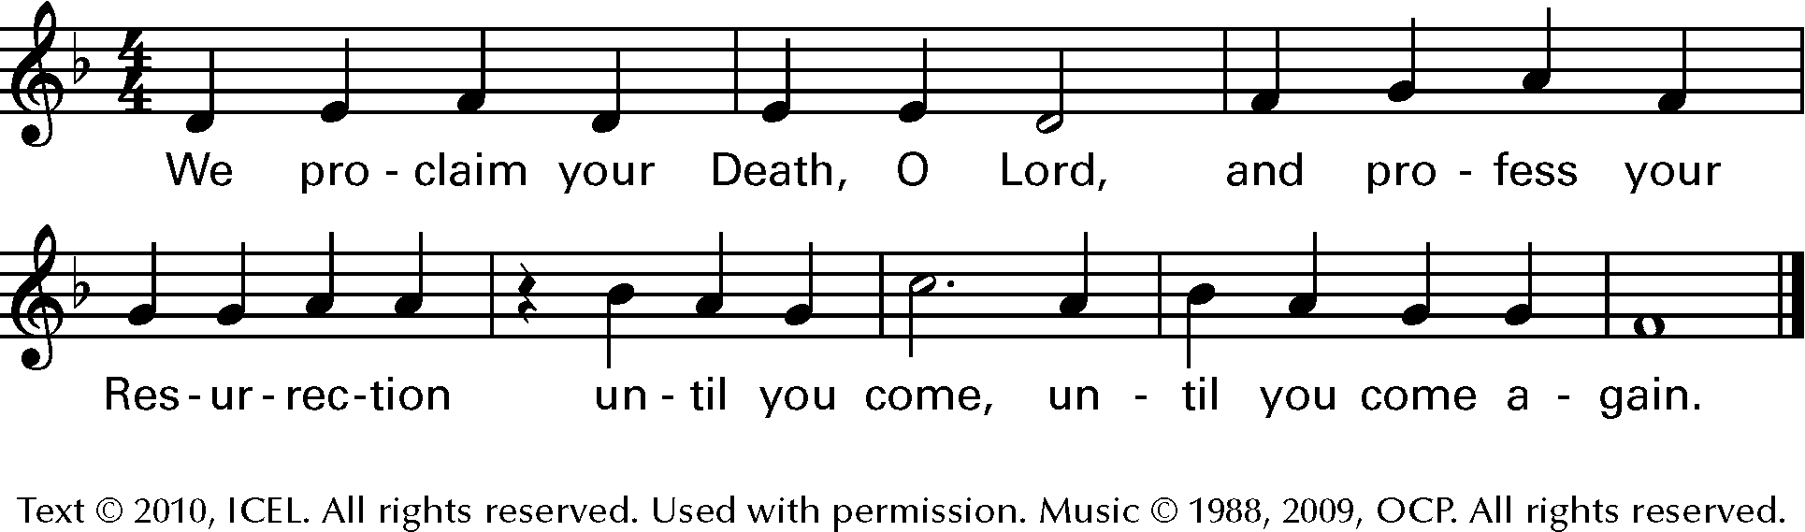
Owen Alstott

