Holy Heritage Mass
Owen Alstott
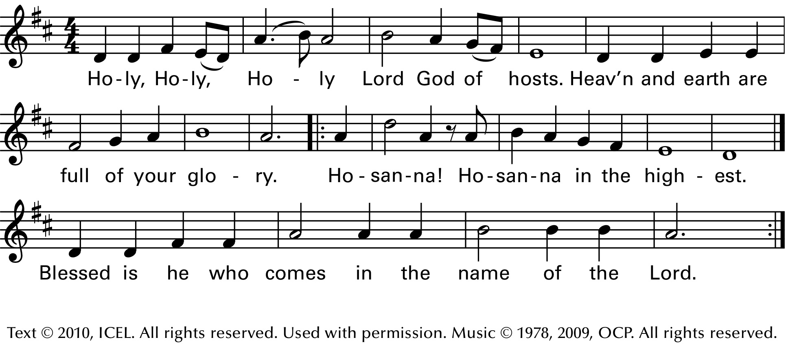

Communion Remember Your Love
Darryl Ducote and Gary Daigle
Text: Based on Psalms 25, 27, 90, 130; Mike Balhoff.
Text and music © 1973, 1978, Damean Music. All rights reserved. Used with permission

Sending Forth The Spirit Sends Us Forth
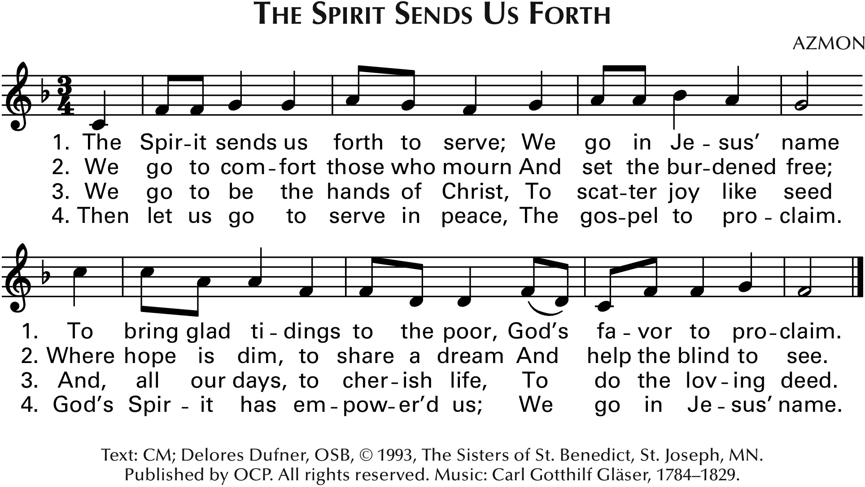
Immaculate Conception
Catholic Church
September 27, 2020
26th Sunday in Ordinary Time

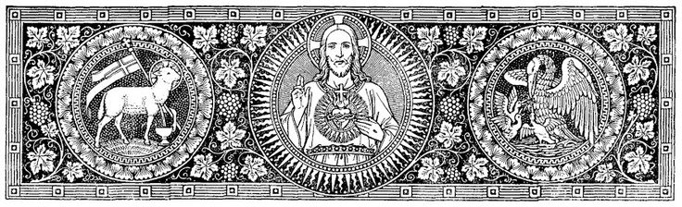

Entrance Praise The Lord, Ye Heavens
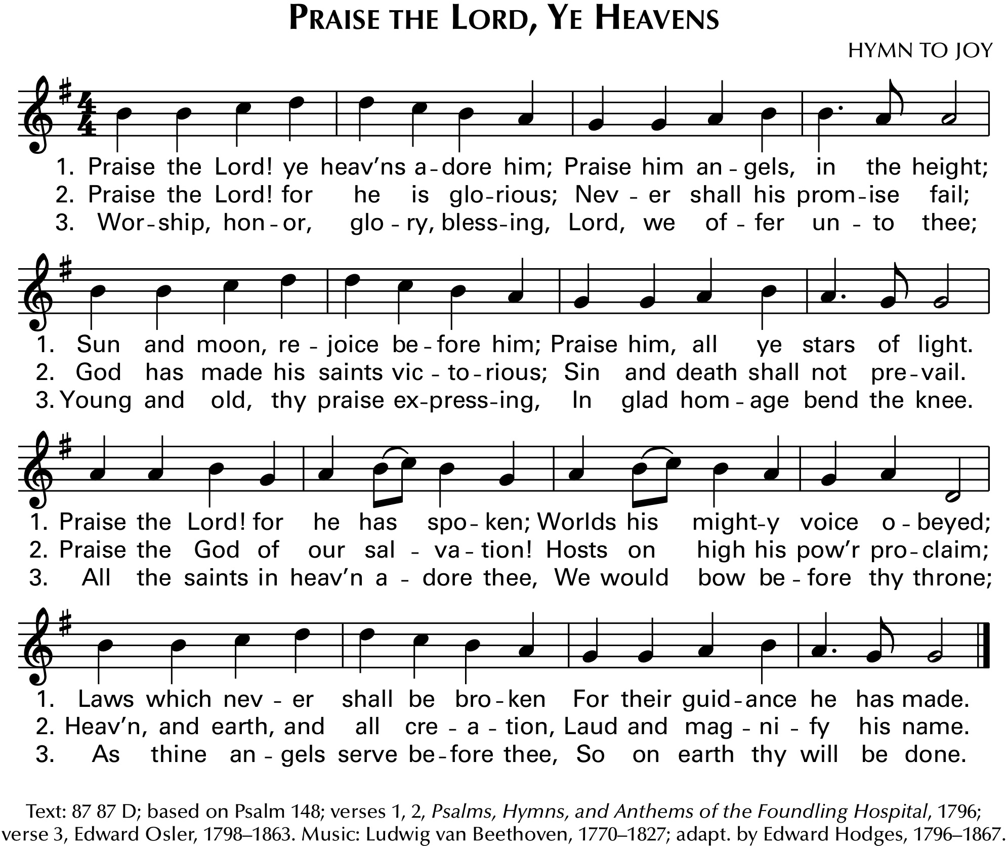

Gloria Heritage Mass
Owen Alstott
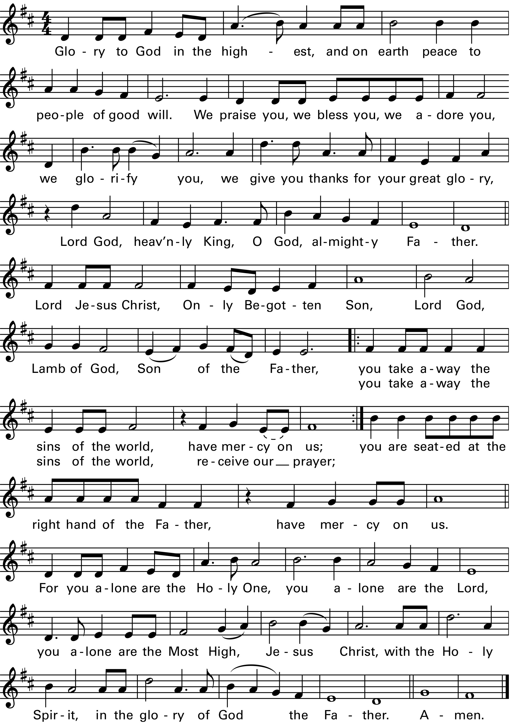

Text copyright 2010, ICEL. All rights reserved. Used with permission. Music copyright 1987, 2009, OCP

Music in this worship aid is reprinted with permission: Onelicense.net#A72564. All rights reserved.
Responsorial Psalm Psalm 25

Remember Your Mercies, O Lord

Preparation of the Altar Lord Of All Hopefulness
